
DEPARTMENT OF INDUSTRIAL CHEMISTRY
FEDERAL UNIVERSITY OYE EKITI, EKITI STATE, NIGERIA
CHM 102 CBT TUTORIAL TRIAL CLASS-2018
NAME OF STUDENT: _________________________________DEPT___________MAT NO_________________
- The main form in which carbohydrates are transported in plants is
(A) Glucose (B) Sucrose (C) Maltose (D) Lactose (E) Galactose
- The following sugars are disaccharides except:
(A) Glucose (B) Sucrose (C) Maltose (D) Lactose (E) Cellulobiose
- The following are isomers of D-glucose except:
- D-Sorbitol (B) L-glucose (C) D-galactose (D) D-fructose (E) β-D-
Glucopyranose
- The product of the following reaction is:
C₁₂H₂₂O₁₁ + heat →
- Carbon (B) Water (C) Carbon and water (D) C₂H₆ (E) C₂H₄
- The product of fermentation of maize is:
(A) Ketone (B) carboxylic acid (C) alcohol (D) aldehyde (E) Starch
- The enzyme responsible for fermentation of bread in yeast is
(A) Zylose (B) Ketose (C) Zymase (D) Yeast (E) Yeastose
- Glycogen is a branched biopolymer consisting of linear chains of ----------- residues
(A) glucose (B) maltose (C) fructose (D) sucrose (E) galactose
- Cellulose has the following properties except that it is
(A) a white solid (B) insoluble in water (C) insoluble in ordinary organic solvents (D) easily hydrolysed (E) a carbohydrate
- The enzyme cellulose that aid the hydrolysis of cellulose is found in
- Ants (B) termites (C) spiders (D) man (E) pig
- Cellulose can be used for the production of the following:
(A) cardboard (B) cellophane (C) cello-tape (D) rayon (E) polythene
- The following terms can be used to describe cellulose except
(A) polymer (B) biomass (C) biopolymer (D) bioenzyme (E) polysaccharide
- The following foods will turn blue black with iodine except
- Gari (B) Guinea corn (C) ground nut (D) guguru (E) pupuru
- Starch is also called the following except
- Amylum (B) Amylose (C) Amylopectin (D) Pectin (E) Polymer
- The following are reducing sugars except
- Glucose (B) Sucrose (C) Maltose (D) Lactose (E) Fructose
- A positive test to Benedict's reagent is indicated by colour change from
(A) blue to brick –red (B) brick-red to blue (C) brick-red to brown (D) brown to blue (E) blue to black
16. The correct structure of 2,4-Dinitrobenzoic acid is------- (A) 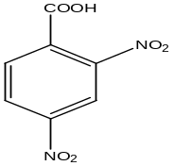 (B) 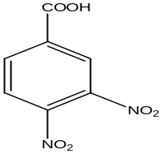(C) 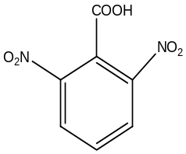 (D) 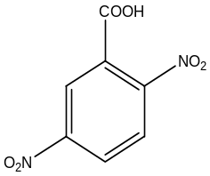 (E) 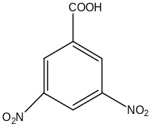

17.Identify the most acidic compound from the following options:
(A) 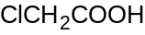 (B) 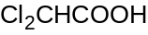 (C) 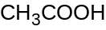 (D) 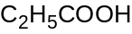 (E) 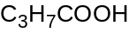
18. Give the products of the following reaction: 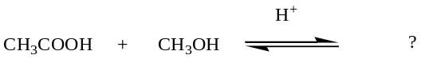
(A) 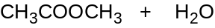 (B) 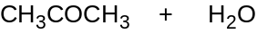 (C) 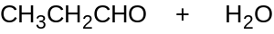 (D) 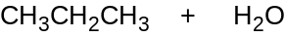 (E) 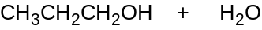
19. The final product of aldo condensation of two molecules of aldehydes will be----------(A) a β-hydroxyaldehyde (B) an α,β-unsaturated aldehyde (C) an α-hydroxyaldehyde (D) a β,β-unsaturated aldehyde (E) a β-hydroxy acid
20. Ketones are less susceptible to nucleophilic attack than aldehydes because-------(A) Ketones are less stable than aldehydes (B) Aldehydes are more stable than ketones (C) the steric hindrance of the alkyl group of ketones may affect their reactivity (D) Ketones are more reactive (E) None of the above.
21. Compound ‘A’ undergoes formation of cyanohydrins which on hydrolysis gives lactic acid 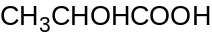. Therefore, Compound ‘A’ is...... (A) Formaldehyde (B) Acetaldehyde (C) Benzaldehyde (D) Acetone (E) Acetophenone.
22. An organic compound ‘X’ is oxidised by using acidified K₂Cr₂O₇. The product obtained reacts with phenyl hydrazine but not answer silver mirror test. The possible structure of X is ------- (A) 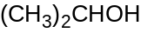 (B) 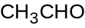(C) 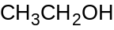(D) 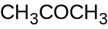 (E) 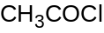
- The following are true about the structure below except one.

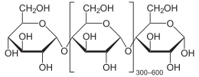

- It is an amylose molecule(B) It is a disaccharide (C) The monomer is glucose (D) It can be hydrolyzed to glucose (E) It is a starch molecule
24. Identify the product of this reaction:
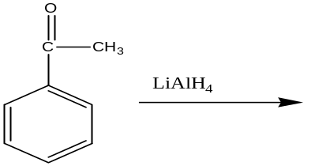 (A) 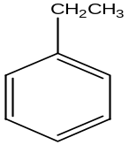 (B) 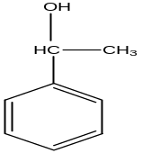 (C) 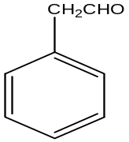 (D) 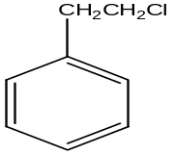 (E) No reaction.

25. Which of the following is a method of preparing ketones? ------- (A) Oxidation of secondary alcohols (B) Oxidation of primary alcohols (C) Reduction of aldehydes (D) Reduction of haloalkanes (E) None of the above
26. The compound which forms methanol and sodium methanoate when treated with conc. NaOH is ----------- (A) Ethanal (B) Methane (C) Propanal (D) Methanal (E) Butanal
27. Reduction of aldehydes and ketones into hydrocarbon using hydrazine and a base is called (A) Cope reduction (B) Dow reduction (C) Wolff-Kishner reduction (D) Clemmensen reduction
(E)Wurth reaction
28. What is the appropriate reagent for the following transformation?
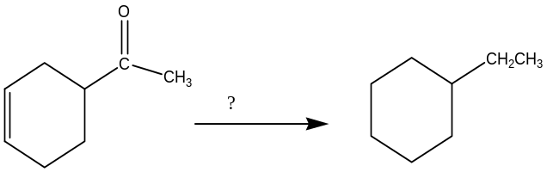 (A) NaBH₄ (B) LiAlH₄ (C) H₂, Ni (D) Zn(Hg), HCl (E) NH₂NH_{2,}NaOH
29. The correct IUPAC name for the following compound: 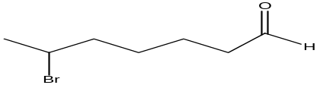 is--------- (A) 2-Bromo heptanal (B) 6-Bromo heptanone (C) 2-Bromo heptanone (D) 6-Bromo heptanal (E) 2-Bromo hexanal
30. Identify the product of this reaction: 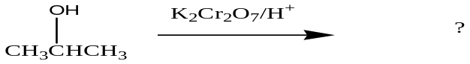
(A) 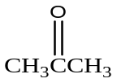 (B) 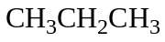 (C) 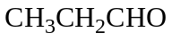(D) 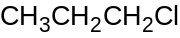 (E) No reaction.
31. The carbonyl compounds that can be oxidised easily to form carboxylic acid are----------(A) ketones (B) Aldehydes (C) haloalkanes (D) Esters (E) Alkanes
- When an amide reacts with bromine in the presence of potassium hydroxide the products? (A) acetamide (B) primary amine (C) nitrile (D) nitro amine (E) propanol amine
- Which general class of compounds does amine belong? (A) oxidizing agent (B) dehydrant (C) reducing agent (D) base (E) acid
- When an amine is reacted with a carboxylic acid then yellow product that is formed is called? (A) amine oxide (B) cyano amine (C) amide (D) tertiary amine (E) solid ammonia
- Grignard reagent when reacted with methanol will yield (A) ethanol (B) secondary alcohols (C) tertiary alcohols (D) propanol (E) primary alcohol
- Saponification reaction is best described as (A) condensation reaction (B) acid promoted hydrolysis reaction (C) base promoted hydrolysis reaction (D) soap making reaction (E) a neutralization reaction involving an acid and a base
- Which of the following is a primary amine? (A) 1,3 pentane diamine (B) N-ethyl, N Methylamine (C) triethylamine (D) N,N. 3,5 trimethyl aniline (E) N-methyl pheyl amine
- (CH₃CO)₂O is
- An ether
- An ether
- An anhydride
- An amide
- Dicarboxylic acid
- CH₃CH₂CH₂C(CH₃)₂CH₂OH is
- 2,2-dimethyl-1-butanol
- 2-methyl-1-butan-1-ol
- 2,2-dimethyl-2-butanol
- 2,2-dimethyl-1-pentanol
- 4,4-dimethyl-1-butanol
- The gas produced when sodium metal is dropped in ethanol is
- H₂ (B) O₂ (C) N₂ (D) CO₂ (E) None of A-D is correct
- The product of decarboxylation of ethanoic acid
- Methane (B) ethane (C) Propane (D) Carbon (E) CO
- The functional group for alcohol and aldehyde, respectively are:
- RCHO,RCOR (B) ROH and RCOOR (C) ROH, RHO (D) RCHO and ROH (E) None of A-D is correct.
43. Clemmensen reduction of a ketone is carried out in the presence of which of the following?-------- (A) H₂ and Pt as catalyst (B) Glycol with KOH (C) Zn-Hg with HCl (D) LiAlH₄ (E) finely divided Ni.
- Organic Chemistry is the study of (A) some carbon compounds (B) All carbon compounds (C) Hydrocarbons (D) Non Hydrocarbons (E) All of the above
- Which of the following reagents should be used to convert CH(CH₂)₃CH₂OH into CH₃(CH₂)₂CHO?
- –KMnO4 (B) LiAIH₄ (C) NaBH₄ (D) –C₃H₆NCrO₃Cl (E) All of the above
- A natural source of phenol is: (A) coal far (B) fermentation of plants (C) bones (D) vegetable oils (E) high temperature distillation
- Phenol is regarded on an acid became (A) it is volatile (B) it easily releases a proton due to resonance (C) it is insoluble in water (D) it is corrosive to the skin (E) of cyclisation
- The structure of phenol can be drawn in these two forms:
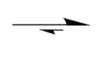
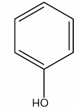
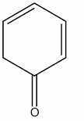

This phenomenon is called: (A) dehydration (B) deprotonation (C) tautomerism (D) reduction (E) isomerism
- The product of fermentation of cassava is:
- Ketone (B) carboxylic acid (C) alcohol (D) aldehyde (E) amine
- Alcohol can be concentrated by: (A) distillation of the product (B) distillation of product with benzene (C) treatment of product with a dehydrating agent and filtration (D) by boiling the product (E) all of the above
- The boiling point of tertiary butanol is 65ºC whereas that of normal butanol is 88ºC, the difference in their b.p is due to: (A) nueleophilicity (B) resonance (C) hydrogen bonding (D) isomerism (E) B and C
- CH₃-CH₂-CH₂OH + KMnO₄
acid

- CH₃-CH₂-CH₃ (B) CH₃-CH₂-CHO (C) CH₃-CH-CH₂ (D) CH₃-CH₂-CH₃ (E) C and D

- Which of these structures is semicarbazide? (A) –H-NNHCONH₂
(B) H₂N-CO-NH₂ (C) H₂NCH₂NHCONH₂ (D) H₂NNH₂CONH₂ (e) H₂N₂CONH₂
- Which of the following compounds will not give a positive iodoform reaction? (A) CH₃CHO (B) CH₃CH₂COCH₂CH₃ (C) CH₃COCH₃ (D) CH₃CH-CH₂CH₃(E) All of the above
- Which of these groups of compounds contain an organic compound which cannot form hydrogen bonds with each other?
(A) carboxylic acids and alcohols (B) alcohols and di substituted amides (C) None substituted and mono substituted amides (D) A and B (E) None of these groups
- Identify the compound that will produce CO₂ from sodium bicarbonate
- 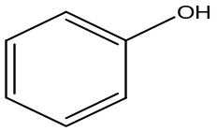 (B) 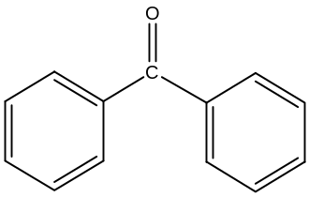 (C) 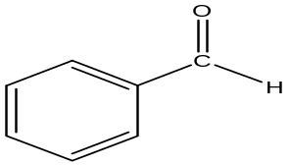

(D) 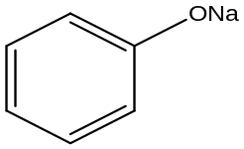 (E) 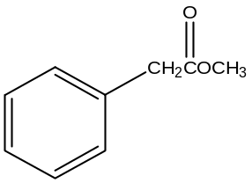
- Which of these has the highest boiling point?
(A) 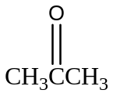 (B) CH₃-CH₂-CH₂-OH (C) CH₃-CH₂-CHO (D) CH₃-C-CI (E) 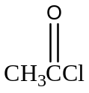
- CH₃COOH has greater miscibility with water than CH₃CH₃-CH₂-COOH. The reason is due to a (A) hydrogen bonging (B) lower molecular weight (C) mutual incompatibility (D) ion
- Which one of the following compounds has a stronger acidity than water?
- 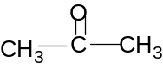 (B) 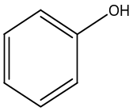(C) 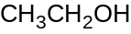 (D) 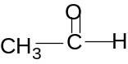 (E) 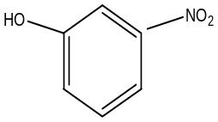

- The easiest way to recognize phenylamine in the laboratory is? (A) strong fishy smell (B) solubility in acid (C) colour (D) solubility in water (E) phenolic odour

